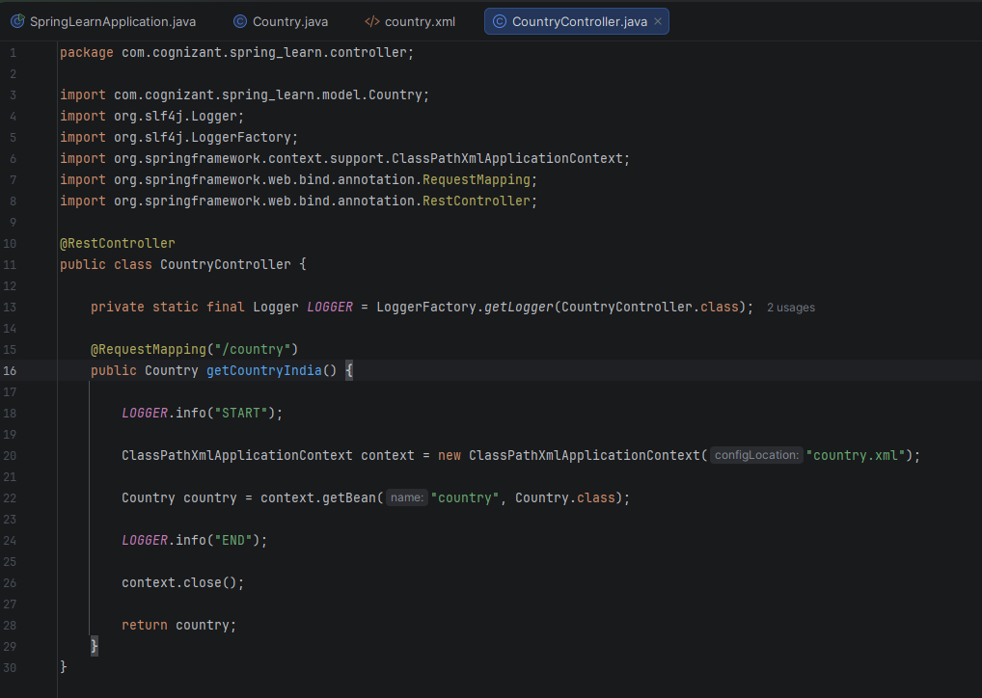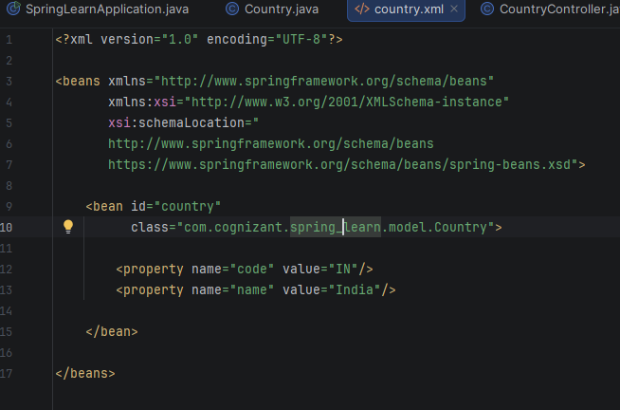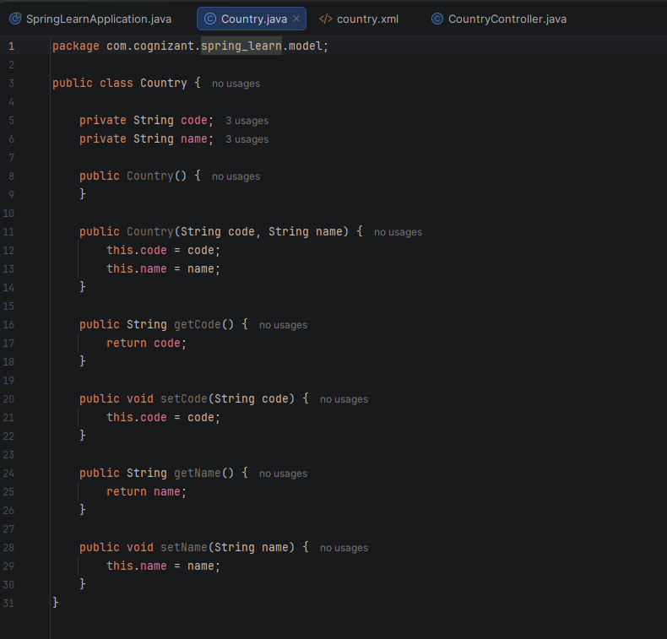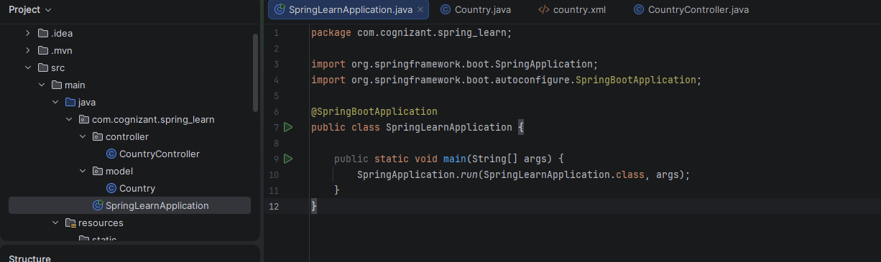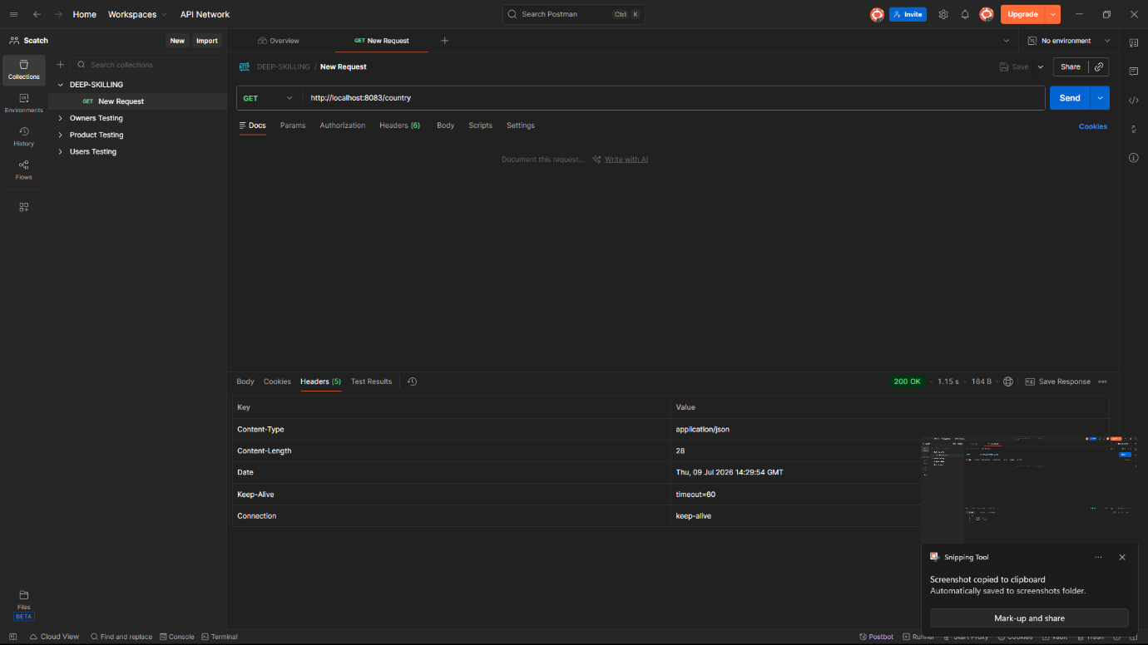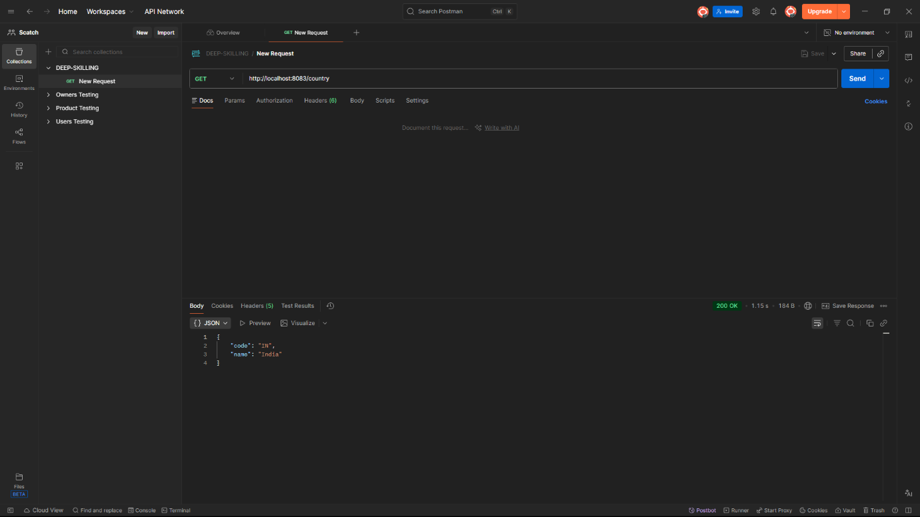

In controller method:
- Client sends : GET /country
- Spring receives the request.
- @RequestMapping("/country") maps it to : getCountryIndia()
- ClassPathXmlApplicationContext loads : country.xml
- Spring creates the bean : country
- Bean is returned.
- Spring converts it to JSON.
- JSON is sent back.

The bean is converted to JSON in following steps:
- Browser sends : GET /country
- Spring calls : getCountryIndia()
- Controller returns a Country object
- Spring Boot uses Jackson (ObjectMapper) automatically
- Jackson converts Country to :
{
"code":"IN",
"name":"India"
}
- JSON is sent as the HTTP response with: “Content-Type: application/json”

